**Phase Factor – Functional Decomposition**

**ECEN 4620**

**FD0**

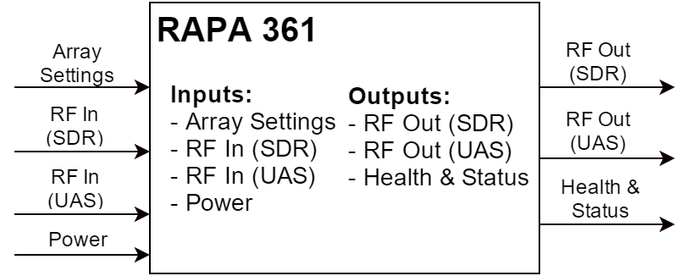

|  |  |
| --- | --- |
| **Module** | Radio Agnostic Phased Array |
| **Inputs** | * Array Settings – On/Off, where to point the antenna * RF In (SDR) – Received RF from the SDR (Tx chain) * RF In (UAS) – Received RF from the UAS (Rx chain) * Power – Power over Ethernet or from external batteries |
| **Outputs** | * RF Out (SDR) – RF sent to the SDR to be interpreted (Rx chain) * RF Out (UAS) – RF sent to the UAS (Tx chain) * Health & Status– Temperature, RF chains turned on, etc. |
| **Functionality** | Radio agnostic phased array designed to interface with one or more mobile UASs. It serves as a data pipe from the user to a generic user provided radio, and connects to the UAS via a phased array antenna. It is primarily powered by external batteries, but depending on the application, hardware exists to power it via “power over Ethernet”. |

**FD1**

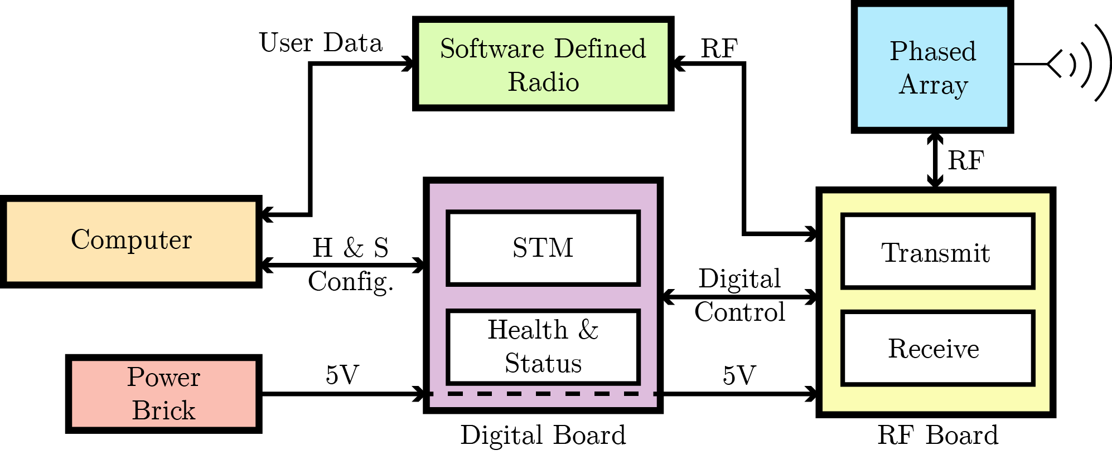

*NOTE: The system operates in half-duplex, so inputs and outputs have to be separated in modes of operation. All digital and RF signals represented above are bi-directional.*

|  |  |
| --- | --- |
| **Module** | Phased Array |
| **Inputs** | *Transmit Mode:* Phase and amplitude adjusted RF signal from the radio  *Receive Mode:* RF signal from the UAS |
| **Outputs** | *Transmit Mode:* RF signal sent to the UAS  *Receive Mode:* Received RF signal to RF adjustment chain and radio |
| **Functionality** | The phased array is an antenna. It will either send or receive a RF signal directionally, depending on how the IQ Modulators are set in the RF board. |

|  |  |
| --- | --- |
| **Module** | RF Board |
| **Inputs** | Setting information from the Digital Board will inform how the IQ modulators are set, changing the beam for both receiving and transmitting.  *Transmit Mode:* Raw RF information from Radio  *Receive Mode:* Received signal from the phased array and UAS |
| **Outputs** | *Transmit Mode:* Phase/amplitude adjusted signal for the array and UAS  *Receive Mode:* Reconstructed signal sent to SDR |
| **Functionality** | The RF Board, in concert with the phased array elements, allows the RF signal to be steered. The RF Chain is responsible for doing phase adjustment and amplitude attenuation via IQ modulation. |

|  |  |
| --- | --- |
| **Module** | Digital Board |
| **Inputs** | Power will be passed to this system (via Ethernet or Power brick)  Settings for the overall system defining pointing direction |
| **Outputs** | Power to the RF Board  Settings for pointing, interpreted for each IQ modulator. |
| **Functionality** | The digital board is primarily responsible for translating a direction (i.e. where to point the beam) into something that the RF board can understand. |

|  |  |
| --- | --- |
| **Module** | SDR/Radio |
| **Inputs** | *Transmit Mode:* Ethernet data from the user to be sent to the UAS  *Receive Mode:* RF signal from the UAS to the system and user |
| **Outputs** | *Transmit Mode:* Interpreted digital signal converted into RF signal for transmission to UAS  *Receive Mode:* The digital signal decoded from the RF input and phased array |
| **Functionality** | The SDR is capable of translating digital commands into RF signals, and vice versa. This is going to be provided by the user, and the rest of the system should not be dependent on the inner workings of the radio. We will be using a radio from XetaWave. |

|  |  |
| --- | --- |
| **Module** | Power Brick |
| **Inputs** | Power from PoE, or external batteries |
| **Outputs** | Regulated 5v power line |
| **Functionality** | The power brick converts high voltage power to a 5v rail. |

|  |  |
| --- | --- |
| **Module** | Computer |
| **Inputs** | User inputs and commands |
| **Outputs** | Data sent to the SDR to be interpreted, and configuration settings for the antenna |
| **Functionality** | This is the primary user interface to the system. It will be how the user changes the beam state (either manually or automatically), and what data is to be sent to the UAS, through the system. Received data is also collected here. |

Acronyms utilized:

* SDR – Software Defined Radio
* UAS - Unmanned Aircraft System
* STM – ST Microelectronics (used to refer to the microcontroller)
* Tx – Transmit
* Rx – Receive
* PoE – Power over Ethernet